Section 8-1: Angles of Polygons

SOL: G.3 The student will solve practical problems involving complementary, supplementary, and congruent angles that include vertical angles, angles formed when parallel lines are cut by a transversal, and angles in polygons.
G.9 The student will use measures of interior and exterior angles of polygons to solve problems. Tessellations and tiling problems will be used to make connections to art, construction, and nature.

Objective:
Find the sum of the measures of the interior angles of a polygon
Find the sum of the measures of the exterior angles of a polygon

Vocabulary:
Diagonal is a segment that connects any two nonconsecutive vertices in a polygon.

Theorems:

Theorem 8.1: If a convex polygon has n sides and S is the sum of the measures of its interior angles, then S = (n-2)*180°

Theorem 8.2: If a polygon is convex, then the sum of the measures of the exterior angles, one at each vertex, is 360°

H-Corollary: The measure of an exterior angle in an n-sided regular polygon is 360° / n

Concept Summary:
If a convex polygon has n sides and sum of the measures of its interior angles is S, then
S = 180(n-2)°
The sum of the measures of the exterior angles of a convex polygon is 360°

For future lessons here are the characteristics of the quadrilaterals we will learn about:

Example 1: A mall is designed so that five walkways meet at a food court that is in the shape of a regular pentagon. Find the sum of measures of the interior angles of the pentagon.

Example 2: The measure of an interior angle of a regular polygon is 135. Find the number of sides in the polygon.

Example 2b: The measure of an interior angle of a regular polygon is 144. Find the number of sides in the polygon.

Example 3: Find the measure of each interior angle.
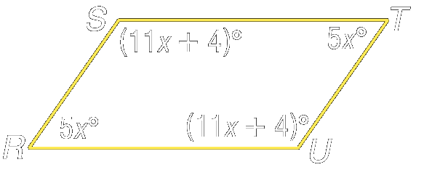

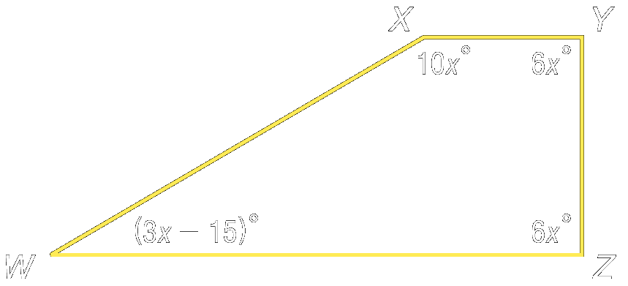
Example 3a: Find the measure of each interior angle.

Example 4: Find the measures of an exterior angle and an interior angle of convex regular nonagon ABCDEFGHJ.

Example 4a: Find the measures of an exterior angle and an interior angle of convex regular hexagon ABCDEF.

Homework: pg 407-408; 13-15, 22-24, 27-30, 35, 36
Section 8-2: Parallelograms

SOL: G.8 The student will
a) investigate and identify properties of quadrilaterals involving opposite sides and angles, consecutive sides and angles, and diagonals;
b) prove these properties of quadrilaterals, using algebraic and coordinate methods as well as deductive reasoning; and
c) use properties of quadrilaterals to solve practical problems.

Objective:
Recognize and apply properties of the sides and angles of parallelograms
Recognize and apply properties of the diagonals of parallelograms

Vocabulary: parallelogram – a quadrilateral with parallel opposite sides

Theorems:

Theorem 8.3: Opposite sides of a parallelogram are congruent
Theorem 8.4: Opposite angles in a parallelogram are congruent
Theorem 8.5: Consecutive angles in a parallelogram are supplementary
Theorem 8.6: If a parallelogram as one right angle, then it has four right angles
Theorem 8.7: The diagonals of a parallelogram bisect each other
Theorem 8.8: Each diagonal of a parallelogram separates the parallelogram into two congruent triangles

Concept Summary:
In a parallelogram, opposite sides are parallel and congruent, opposite angles are congruent, and consecutive angles are supplementary
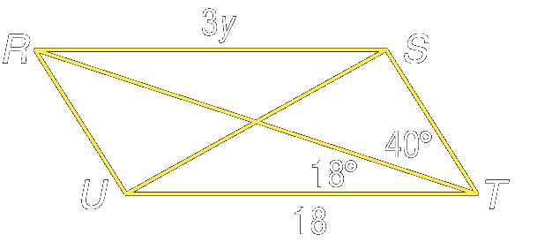
The diagonals of a parallelogram bisect each other.

Example 1: RSTU is a parallelogram. Find m∠URT , m∠SRT and y.

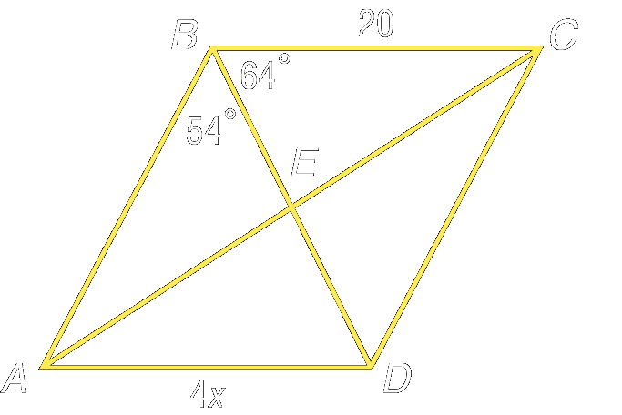
Example 2: ABCD is a parallelogram. Find m∠BDC, m∠BCD and x.

Example 3: What are the coordinates of the intersection of the diagonals of parallelogram MNPR, with vertices M(–3, 0), N(–1, 3), P(5, 4), and R(3, 1)?

Homework: pg 415-416; 16, 19-24, 29-31, 46
Section 8-3: Tests for Parallelograms

SOL: G.8 The student will
a) investigate and identify properties of quadrilaterals involving opposite sides and angles, consecutive sides and angles, and diagonals;
b) prove these properties of quadrilaterals, using algebraic and coordinate methods as well as deductive reasoning; and
c) use properties of quadrilaterals to solve practical problems.

Objective:
Recognize the conditions that ensure a quadrilateral is a parallelogram
Prove that a set of points forms a parallelogram in the coordinate plane

Vocabulary: None new

Theorems:

Theorem 8.9: If both pairs of opposite sides of a quadrilateral are congruent, then the quadrilateral is a parallelogram

Theorem 8.10: If both pairs of opposite angles of a quadrilateral are congruent, then the quadrilateral is a parallelogram

Theorem 8.11: If the diagonals of a quadrilateral bisect each other, then the quadrilateral is a parallelogram

Theorem 8.12: If one pair of opposite sides of a quadrilateral is both parallel and congruent, then the quadrilateral is a parallelogram

Concept Summary:
A quadrilateral is a parallelogram if any of the following is true:
Both pairs of opposite sides are parallel and congruent
Both pairs of opposite angles are congruent
Diagonals bisect each other
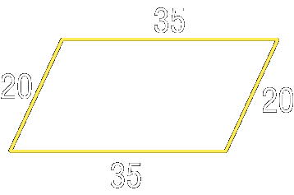
A pair of opposite sides is both parallel and congruent

Example 1: Determine whether the quadrilateral is a parallelogram. Justify your answer.

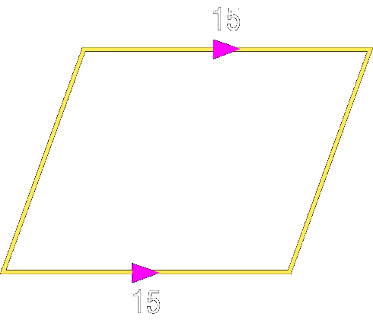

Example 2: Determine whether the quadrilateral is a parallelogram. Justify your answer

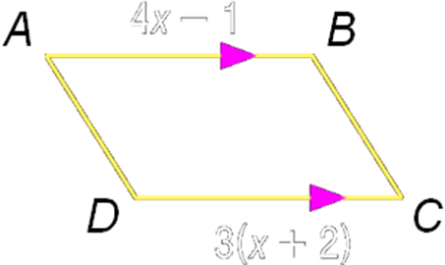

Example 3: Find x so that the quadrilateral is a parallelogram.

Homework: pg 421-423; 15-22, 26-27, 45-46
Section 8-4: Rectangles

SOL: G.8 The student will
a) investigate and identify properties of quadrilaterals involving opposite sides and angles, consecutive sides and angles, and diagonals;
b) prove these properties of quadrilaterals, using algebraic and coordinate methods as well as deductive reasoning; and
c) use properties of quadrilaterals to solve practical problems.

Objective:
Recognize and apply properties of rectangles
Determine whether parallelograms are rectangles

Vocabulary:
Rectangle – quadrilateral with four right angles.

Theorems:

Theorem 8.13: If a parallelogram is a rectangle, then the diagonals are congruent
Theorem 8.14: If the diagonals of a parallelogram are congruent, then the parallelogram is
a rectangle. (converse of Theorem 8.13 – makes a biconditional statement)

Concept Summary:
A rectangle is a quadrilateral with four right angles and congruent diagonals
If the diagonals of a parallelogram are congruent, then the parallelogram is a rectangle


Example 1: Quadrilateral RSTU is a rectangle. If RT = 6x + 4 and SU = 7x - 4 find x.

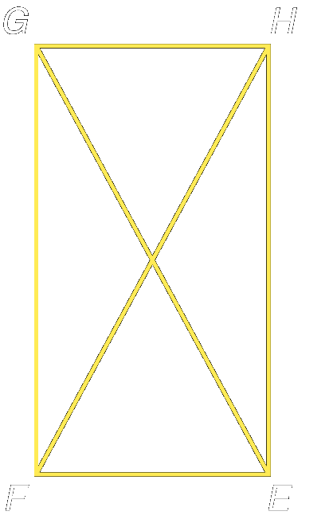
Example 2: Quadrilateral EFGH is a rectangle. If FH = 5x + 4 and GE = 7x – 6, find x.

Example 3: Solve for x and y in the following rectangles
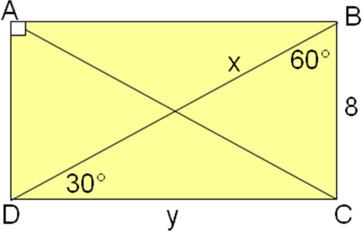

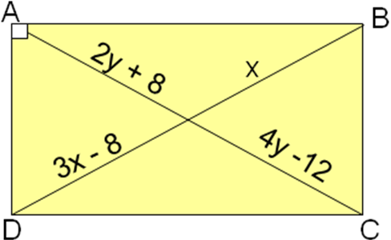

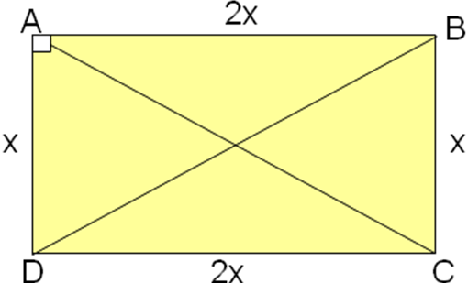

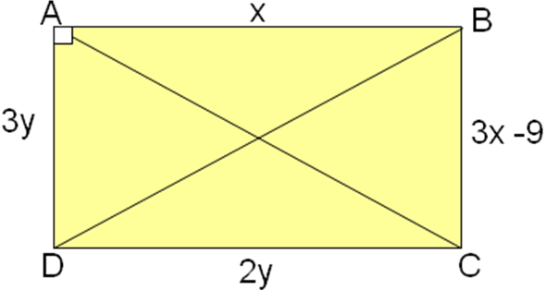

Example 4: Quadrilateral LMNP is a rectangle. Find x.

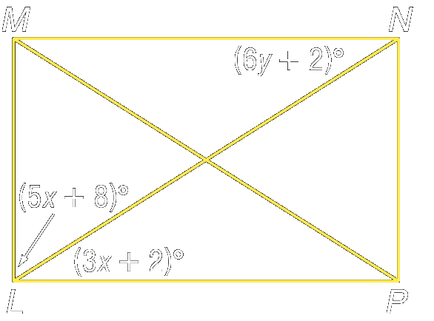

Example 5: Quadrilateral LMNP is a rectangle. Find y.

Homework: pg 428-429; 10-13, 16-20, 42
Section 8-5: Rhombi and Squares

SOL: G.8 The student will
a) investigate and identify properties of quadrilaterals involving opposite sides and angles, consecutive sides and angles, and diagonals;
b) prove these properties of quadrilaterals, using algebraic and coordinate methods as well as deductive reasoning; and
c) use properties of quadrilaterals to solve practical problems.

Objective:
Recognize and apply the properties of rhombi
Recognize and apply the properties of squares

Vocabulary:
Rhombus – quadrilateral with all four sides congruent
Square – a quadrilateral that is both a rhombus and a rectangle

Theorems:

Theorem 8.15: The diagonals of a rhombus are perpendicular
Theorem 8.16: If the diagonals of a parallelogram are perpendicular, then the parallelogram
is a rhombus. (converse of Theorem 8.15 – makes a biconditional statement)
Theorem 8.17: Each diagonal of a rhombus bisects a pair of opposite angles

Concept Summary:
A rhombus is a quadrilateral with each side congruent, diagonals that are perpendicular, and each diagonal bisecting a pair of opposite angles.
A quadrilateral that is both a rhombus and a rectangle is a square.

Example 1: Use rhombus LMNP to find the value of y if m∠1 = y² - 54.

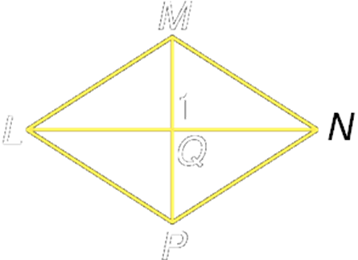

Example 2: Use rhombus LMNP to find m∠PNL if m∠MLP = 64

Example 3: Use rhombus ABCD and the given information to find the value of each variable.
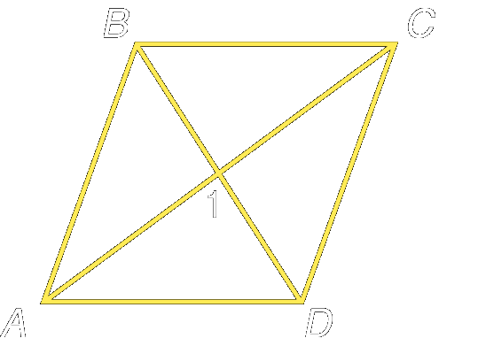
- Find x if m∠1 = 2x² - 38

- Find m∠CDB if m∠ABC = 126

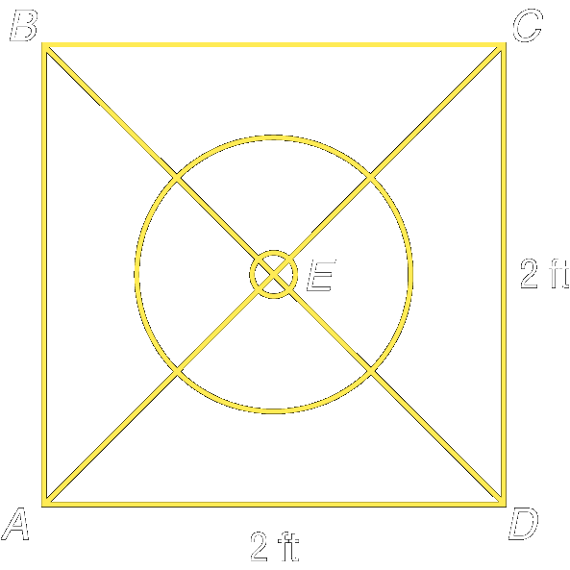
Example 4: A square table has four legs that are 2 feet apart. The table is placed over an umbrella stand so that the hole in the center of the table lines up with the hole in the stand. How far away from a leg is the center of the hole?

Example 5: Kayla has a garden whose length and width are each 25 feet. If she places a fountain exactly in the center of the garden, how far is the center of the fountain from one of the corners of the garden?

Homework: pg 434-436; 14-23, 26-31
Section 8-6: Trapezoids

SOL: G.8 The student will
a) investigate and identify properties of quadrilaterals involving opposite sides and angles, consecutive sides and angles, and diagonals;
b) prove these properties of quadrilaterals, using algebraic and coordinate methods as well as deductive reasoning; and
c) use properties of quadrilaterals to solve practical problems.

Objective:
Recognize and apply the properties of trapezoids
Solve problems involving medians of trapezoids

Vocabulary:
Trapezoid – a quadrilateral with only one pair of parallel sides
Isosceles Trapezoid – a trapezoid with both legs (non parallel sides) congruent
Median – a segment that joins the midpoints of the legs of a trapezoid

Theorems:

Theorem 8.18: Both pairs of base angles of an isosceles trapezoid are congruent
Theorem 8.19: The diagonals of an isosceles trapezoid are congruent
Theorem 8.20: The median of a trapezoid is parallel to the base and its measure is one-half the sum of the measures of the bases.

Concept Summary:
In an isosceles trapezoid, both pairs of base angles are congruent and the diagonals are congruent.
The median of a trapezoid is parallel to the bases and its measure is one-half the sum of the measures of the bases

Example 1: The top of this work station appears to be two adjacent trapezoids. Determine if they are isosceles trapezoids.

Example 2: The sides of a picture frame appear to be two adjacent trapezoids. Determine if they are isosceles trapezoids.

Example 3: DEFG is an isosceles trapezoid with median MN.
Find DG if EF = 20 and MN = 30.
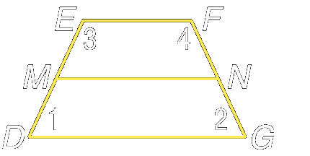

Example 4: DEFG is an isosceles trapezoid with median MN.
Find m∠1, m∠2, m∠3, and m∠4, if m∠1 = 3x+5 and m∠3 = 6x – 5.

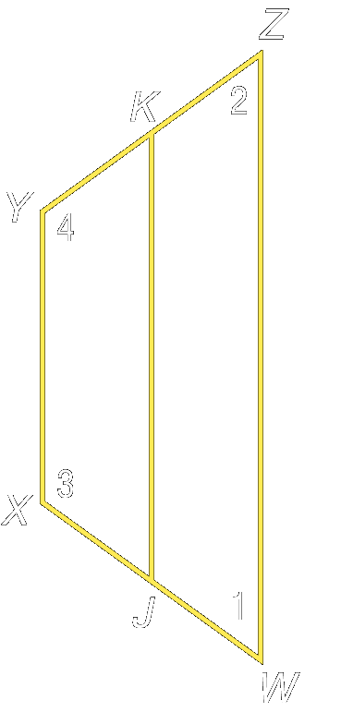
Example 5: WXYZ is an isosceles trapezoid with median JK.

- Find XY if JK = 18 and WZ = 25

- Find m∠1, m∠2, m∠3, and m∠4, if m∠2 = 2x – 25 and m∠4 = 3x + 35.

Homework: pg 442-444; 10, 13-16, 22-25
Section 8-7: Coordinate Proof with Quadrilaterals

SOL: G.8 The student will
b) prove these properties of quadrilaterals, using algebraic and coordinate methods as well as deductive reasoning; and
c) use properties of quadrilaterals to solve practical problems.

Objective:
Position and label quadrilaterals for use in coordinate proofs
Prove theorems using coordinate proofs

Vocabulary:
Kite – quadrilateral with exactly two distinct pairs of adjacent congruent sides.

Key Concepts:
Distance formula (equal length sides ➔ congruent sides)
Slope formula (parallel ➔ equal slopes; perpendicular ➔ negative reciprocals)
Midpoint formula

Concept Summary:
Position a quadrilateral so that a vertex is at the origin and a least one side lies along an axis.

Homework: pg 450-451; 9, 11-14, 28, 29, 31-33

Remember, each geometric figure has the properties of the figures above it in the hierarchy. For example, all Squares have the same properties as both Rectangles and Rhombi, and Parallelograms. The Venn diagram attempts to show the same thing for just quadrilaterals.

Lesson 8-1:

Find the measure of an interior angle given the number of sides of a regular polygon.
- 10 2. 12

Find the measure of the sums of the interior angles of each convex polygon
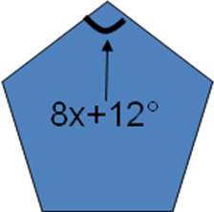
3. 20-gon 4. 16-gon
5. Find x, if QRSTU is a regular pentagon
6. What is the measure of an interior angle of a regular hexagon?
a. 90 b. 108 c. 120 d. 135

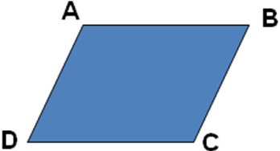
Lesson 8-2:

Complete each statement about parallelogram ABCD
1. AB ≅ ______
2. AD ≅ ______
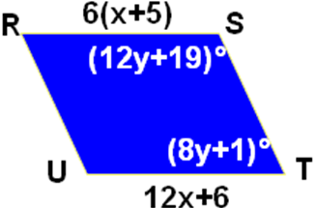
3. ∠D ≅ ______
In the figure RSTU is a parallelogram
Find the indicated value.
4. x 5. y
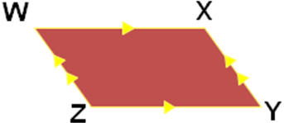
6. Which congruence statement is not necessarily true, if WXYZ is a parallelogram?
a. WZ ≅ XZ b. WX ≅ YZ c. ∠W ≅ ∠Y d. ∠X ≅ ∠Z

Lesson 8-3:

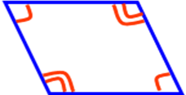
Determine whether each quadrilateral is a parallelogram.
Justify your answer.
- 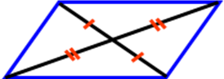 2.
Determine whether the quadrilateral with the given vertices is a parallelogram using the method indicated.
3. A(,), B(,), C(,), D(,) Distance formula

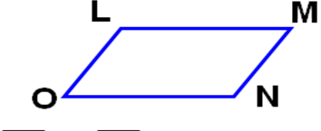
4. R(,), S(,), T(,), U(,) Slope formula

5. Which set of statements will prove LMNO a parallelogram?
a. LM // NO and LO ≅ MN b. LO // MN and LO ≅ MN
c. LM ≅ LO and ON ≅ MN d. LO ≅ MN and LO ≅ ON

Lesson 8-4:
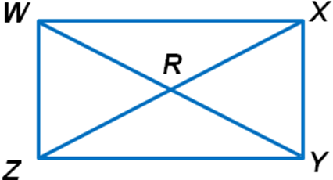
WXYZ is a rectangle. Find each value.
1. If ZX = 6x – 4 and WY = 4x + 14, find ZX.

2. If WY = 26 and WR = 3y + 4, find y.
3. If m∠WXY = 6a² - 6, find a.

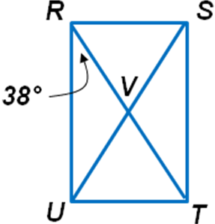
RSTU is a rectangle. Find each value.
4. m∠VRS
5. m∠RVU
6. What are the coordinates of W if WXYZ is a rectangle and X(2,6), Y(4,3), and Z(1,1)?
a. (1,4) b. (-1,-4) c. (-1,4) d. (1,-4)

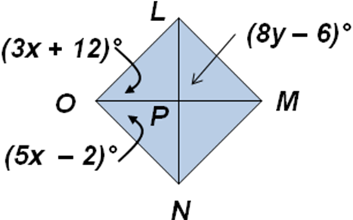
Lesson 8-5:

LMNO is a rhombus.
- Find x
- Find y
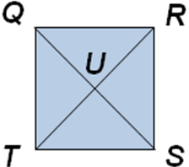
QRST is a square.
- Find n if m∠TQR = 8n + 8.
- Find w if QR = 5w + 4 and RS = 2(4w – 7).
- Find QU if QS = 16t – 14 and QU = 6t + 11.
6. What property applies to a square, but not to a rhombus?
a. Opposite sides are congruent b. Opposite angles are congruent
c. Diagonals bisect each other d. All angles are right angles

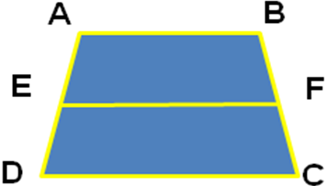
Lesson 8-6:

ABCD is an isosceles trapezoid with median EF.
- Find m∠D if m∠A= 110°.
- Find x if AD = 3x² + 5 and BC = x² + 27.
- Find y if AC = 9(2y – 4) and BD = 10y + 12.
- Find EF if AB = 10 and CD = 32.
- Find AB if AB = r + 18, CD = 6r + 9 and EF = 4r + 10.
- Which statement is always true about trapezoid LMNO with bases of LM and NO?
a. LO // MN b. LO ≅ MN c. LM // NO d. LM ≅ NO

Extra Credit Assignment: Name: _____________________

